Kansas ECO-Meet

November 3rd, 2022

Camp Wood

Elmdale, Kansas

ECO-Meet Mission Statement…

“To challenge and inspire an interest in, appreciation of and an

understanding of the natural sciences and the Kansas environment thru interscholastic competition.”

Vital Statistics…

When is the 2022 State ECO-Meet?

Thursday, November 3rd.. The event will take place rain or shine! All events except the Scavenger Hunt will be conducted in an enclosed structure.

Where is the 2022 State ECO-Meet being held?

At Camp Wood near Elmdale. See below for maps and travel directions or visit: www.campwood.org Overnight lodging is available at the camp in the Jones Village Cabins and Calhoun Health Center. Call the camp for rates.

What time does the 2022 State ECO-Meet begin?

Promptly at 9:00 am. Please plan on arriving between 8:00 am and 9:00 am to check-in and for team pictures. If your school is late, teams and individuals will have that much less time for their first scheduled event, which begins at 9:20 am.

Where do schools and individuals park?

Attendees can park in any of the four designated parking lots on the grounds

Where do the competitors and sponsors check-in?

Check-in at the Ritchie Lodge and enjoy the morning’s refreshments beginning at 8:00 am.

What are the fees for the 2022 State ECO-Meet?

A participation fee of $17.00/person will be collected at check-in from everyone, including coaches, parents, bus drivers, etc. This money helps defray the expense of renting the facilities for the day.

NOTE: Please make checks payable to Kansas ECO-Meet.

Do I need to bring anything special?
Everyone attending the State ECO-Meet including coaches, parents, bus drivers, and volunteers must fill out an Adult or Youth Health & Participation Form. This is a requirement of Camp Wood. The forms are available as PDF downloads on the ECO-Meet website: (www.ecomeet.org) You only need to fill in the top portion of the form that applies to all activities on Camp Wood. You do not need to fill out the portions dealing with horseback activities or the Alpine Tower/Ropes course. Bring the completed form with you the day of the State ECO-Meet and turn it in at check-in.
If you do not bring the completed form you will not be allowed to participate.

Will lunch be provided?

Yes, a hot lunch will be served to everyone. If you have special dietary needs, please contact Geneva Benton at (620) 273-8641 so that arrangements can be made.

How should you dress?

The 2022 State ECO-Meet will be held regardless of the weather, so dress accordingly.

Remember…

- The maximum number of teams allowed to attend State is set at 28. Therefore, in any year where more than nine regional events are held, only the first and second place teams are guaranteed a slot at State. If more than nine regional events are held, the third place teams from each will be ranked by total score and admitted to State based on available space.

Teams can only compete for team scholarships and individuals qualifying at their regional meet for State will only compete for scholarships in the areas in which they qualified.

No substitutions of team members or individuals can be made from the regional meet. If a member of a qualifying team cannot attend State, the team must compete with only the remaining team members.

Teams will present their regional interpretive presentation. However, improvements are encouraged. Props and make-up may be used but you must be ready to present when called upon.

Teams will give their interpretive event presentations in the order shown on the schedule.

All other participants in the interpretive event are to act as audience for performing teams.

Rules and regulations of the State ECO-Meet are subject to change. Any and all changes will be explained in advance to all teams and coaches. The ECO-Meet committee welcomes any suggestions or comments about the event and will consider any submitted ideas.

After-meet packets will be sent out via email to all coaches with their team and individual students’ results. Be sure to provide us your email address!

Professionals from various fields of interest will conduct the ECO-Meet.

All decisions by the judges are final.
The 2022 KANSAS ECO-MEET is Co-Sponsored by:
Kansas Wildscape Foundation
Kansas Department of Wildlife and Parks
Chickadee Checkoff
Kansas Herpetological Society
Milford Friends Group
The Nature Conservancy, Kansas Chapter

About the awards…

Scholarships, medals, and certificates will be presented to each member of the
1st, 2nd, and 3rd place overall teams. Scholarships are as follows:
1st place - $300; 2nd place - $200; 3rd place - $100.

Scholarships, medals, and certificates will be presented to the 1st and 2nd place individual winners in the two test events. Scholarships are as follows:
1st place - $200, 2nd place - $100.

A traveling trophy will be awarded to the winning 1st place overall team.
The trophy will reside at the team’s school until the 2023 State ECO-Meet.

State scholarship claim forms can be downloaded from the ECO-Meet website at www.kansasecomeet.org

More questions?

For more information contact:

Pat Silovsky at 785-238-5323 pat.silovsky@ks.gov or

Mike Rader at 620-672-0708; mike.rader@ks.gov

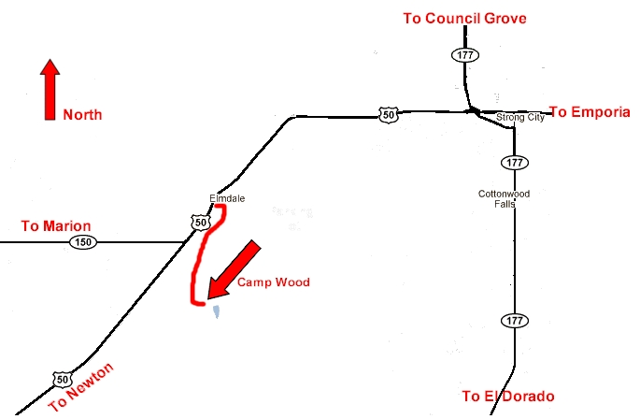
To get to
Camp Wood:
Exit U.S. 50 at Elmdale (south side of highway), go across the railroad tracks and take the first right (Camp Wood Road).
Follow it to the south and west to the entrance
(~2 miles).

Elmdale is between Emporia and Newton on U.S. 50 Highway.

For more information about Camp Wood call (620) 273-8641
or see their website at www.campwood.org

2022 KANSAS ECO-MEET SCHEDULE OF EVENTS

WHEN: November 3rd, 2015 (Thursday)
WHERE: Camp Wood 620-273-8641

8:00 to 9:00 AM - Check-in at the Ritchie Lodge
Morning refreshments provided
Photographs taken of all participants
9:00 to 9:15 AM - Welcome and last minute guidance
9:20 to 10:20 AM - Event #1
10:20 to 11:20 AM - Event #2
11:20 to 12:20 - Lunch at Ritchie Lodge
12:20 to 1:20 PM - Event #3
1:20 to 2:20 PM - Event #4
ASAP - Awards Ceremony at Ritchie Lodge
Photographs taken of all winners
3:00 PM - Departure

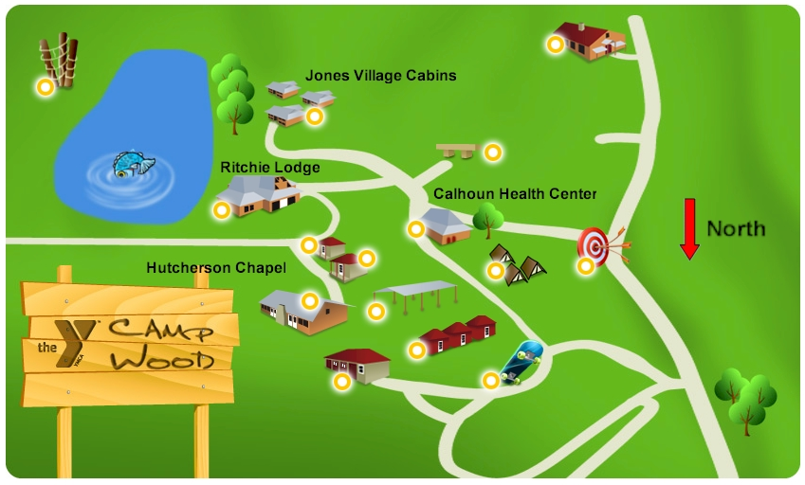
Interpretive Event – Hutcherson Chapel
Registration, Both Table Tests, Lunch & Awards Ceremony – Ritchie Lodge
Scavenger Hunt – next to Jones Village Cabins

