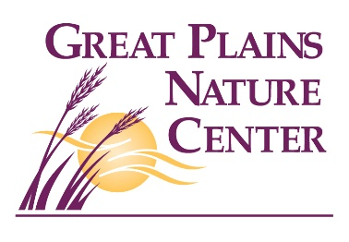
Great Plains Nature Center - ECO-MEET REGISTRATION FORM

October 27th, 2024

REGISTRATION FEE – Paid for by Kiwanis Club of Wichita

Name of School:___________________________________________
T-Shirt Size: _________________
Name of Coach:___________________________________________

Email address of Coach:_____________________________________

Phone number of Coach:_____________________________________

Teams should have 3 or 4 students each. Please reach out if you would like more than two teams.

TEAM A
Student Name T-Shirt Size Graduation Year

1.___________________________________________________________________________________

2.___________________________________________________________________________________

3.___________________________________________________________________________________

4.___________________________________________________________________________________

TEAM B
Student Name T-Shirt Size Graduation Year

1.___________________________________________________________________________________

2.___________________________________________________________________________________

3.___________________________________________________________________________________

4.___________________________________________________________________________________

T-shirts and lunch provided by Kiwanis Club of Wichita. Please list any food allergies for attendees below:

__________________________________________________________________________________________

__________________________________________________________________________________________

Please submit your registration by 10/17/2025. Questions? Call 316-683-5499.

Send to: Kayleigh Hartley
Great Plains Nature Center
6232 E 29th St N
Wichita, KS 67220 OR kayleigh@gpnc.org

