A Complex Prairie Ecosystem
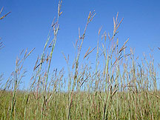
Prairies historically covered 170 million acres of North America. This sea of grass stretched from the Rocky Mountains to east of the Mississippi River and from Saskatchewan, south to Texas, covering parts of 14 states in the Midwest. It was the continent's largest continuous ecosystem supporting an enormous quantity of plants and animals. Prairies began appearing in the mid-continent from 8,000 to 10,000 years ago and have developed into one of the most complicated and diverse ecosystems in the world, surpassed only by the rainforest of Brazil.

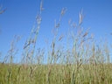
Big bluestem grasses
Tallgrass prairies are an extremely complicated web of life. At first sight, one sees a landscape dominated by grasses. Eighty percent of the foliage is indeed made up of grasses, from 40 to 60 different species. The other 20% of the primary vegetation is made up of over 300 species of forbs or flowers. The prairie also has over 100 species of lichens and liverworts as well as numerous species of woody trees and shrubs along creeks and protected areas. Prairie landscapes vary in soil types and depth, moisture, and slope. Glaciers deposited the parent material for prairie soil in the form of till (unsorted sediment) and winds dropped loess and organic matter resulting in the deepest level of topsoil recorded anywhere.
European man discovered the rich, deep loess soil that exist in the prairies about 150 years ago. Finding the prairie soils outstanding for crop production, they plowed the prairie everywhere they could for the production of wheat, corn, and other domestic crops. Today, the most fertile and well-watered region, the tallgrass prairie, has been reduced to but 1% of its original area. This makes it one of the rarest and most endangered ecosystems in the world. The largest remaining area still left unplowed is in the rocky and hilly region of Kansas called the Flint Hills. This physiographic region averages 60 miles wide and stretches from the Nebraska border, south into northern Oklahoma.
Prairies exist in areas too wet for desert yet too dry to support healthy forests. Prairies respond to their environment, which includes soil type, water availability, and natural forces such as grazing and fire. These have resulted in three distinct prairie regions. In the West, in the dry Rocky Mountain rain shadow, there is the ankle high short-grass prairie with its buffalo grass and blue grama. The eastern prairies are wetter and support tallgrass prairies with Big bluestem, Indian grass, and Switch grass growing to heights of eight feet at times. Between lies the mid-grass prairie dominated by side-oats grama and wheatgrass, with a mixture of shortgrass prairies in dry sites and tallgrass in wetter sites. The prairie is well known for its fauna. Some authors have estimated that there were between 30-60 million bison roaming the prairies. Elk, deer, and antelope also grazed in astounding numbers. Large predators preying on the grazers included the grizzly bear and wolf. Hoards of smaller wildlife from birds to pocket gophers were inhabitants adapted to this unique ecosystem.

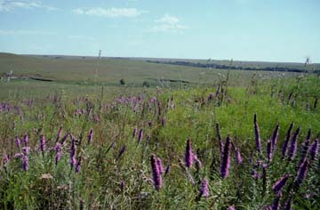
Blazing star wildflowers on the prairie
Fires sweep across the prairie consuming everything in its path. On top of this there is a barrage of organisms feeding on these plants as fast as they grow. The secret to the survival of the prairie plants in such a hostile environment is that 75-80% of the prairies biomass, or plant material, is underground and the growing tip of the grass lies low to the earth in spring. The visible plants seen on the landscape are merely the photosynthetic leaves gathering sunlight for a much larger community underground. Just beneath the surface lies the main stems or rhizomes, running horizontally. Here they lie protected from drying, grazing, trampling, fire, and frost. Tough fibrous roots descend from these rhizomes deep into the ground. Roots of some plants such as dotted gayfeather have been reported to go 10 to 15 feet deep. On these roots, are microscopic "rootlets" numbering in the billions and utilized by the plant. Even smaller than rootlets are mycorrhizae that support plant growth by drawing in nutrients too little for even rootlets to obtain. The roots of plants are so numerous, that were one plant's roots placed end to end they would stretch for miles. The competition for nutrients and resources is fierce, so thickly interwoven are plant roots that early settlers were able to cut bricks out of the sod to build homes and schools.

